Infrastructure Documentation & Environment Matrix
1. Overview:-
This document defines the infrastructure strategy, environment segmentation, service dependencies, and observability roadmap for the application consisting of:
- Frontend service
- Backend API service
- Blockchain node integration
The objective is to ensure consistency across environments and provide a scalable foundation for future production deployment.

2. Environment Strategy :-

The system is designed to operate across three logical environments:
- Local (Development)
- Staging (Planned)
- Production (Planned)

Local Environment (Development Tier):-
Purpose:-
* Used for feature development, integration testing, and debugging.
Infrastructure Components:
- Docker containers
- docker-compose for multi-service orchestration
- Minikube (local Kubernetes validation)
- Local blockchain node
- Local container networking
Deployment Model:
- Manual deployment via Docker or kubectl
- Single-command startup (docker-compose up)
Logging & Monitoring:
- Local container logs
- Basic runtime logs
- Optional Prometheus/Grafana validation
Security Level:
Non-production configuration with relaxed security controls.

2.2 Staging Environment (Planned – Pre-Production)
Purpose:
Pre-production validation, integration testing, and user acceptance testing (UAT).
Planned Infrastructure:
- Cloud-managed Kubernetes cluster (EKS / AKS / GKE equivalent)
- Container images from registry
- CI/CD auto-deployment from dev branch
- Isolated namespace
Deployment Model:
- Automated via CI/CD pipeline
- Pull-based deployment from container registry
Monitoring & Logging:
- Centralized logging
- Metrics collection via Prometheus
- Dashboard visualization via Grafana
- Alert thresholds defined
Security Level:
- Restricted external access
- Secure environment variables
- Role-based access control

2.3 Production Environment (Planned – Live Tier)
Purpose:
Live system serving end users.
Planned Infrastructure:
- Managed Kubernetes cluster
- Load balancer
- Auto-scaling enabled
- Encrypted communication (HTTPS)
- Secrets management
Deployment Model:
- CI/CD pipeline deployment from main branch
- Mandatory PR approvals
- Branch protection rules enforced
Monitoring & Observability:
Full metrics monitoring
Centralized logging with retention policy
Alerting (email/Slack integration planned)
Security Level:
- Least-privilege access
- Strict RBAC
- Encrypted secrets
- Production-grade configuration

Define service dependency matrix (backend ↔ blockchain ↔ frontend)
Service | Depends On | Communication Protocol | Dependency Type | Purpose
Frontend | Backend API | HTTP / REST | Synchronous | Sends user requests and receives processed responses
Backend | Blockchain Node | Web3 / RPC | Transactional | Executes smart contracts and retrieves blockchain state
Backend | Database (Optional) | TCP / SQL | Persistent | Stores user and transaction metadata
Blockchain | None | — | Independent | Validates and processes transactions

Architecture Diagram
This diagram shows how the system works step by step.
- User
The user opens the application and performs actions.
- Frontend Service
The frontend is the user interface (UI).
It collects user input and sends requests to the backend.
- Backend API Service
The backend processes the request.
It contains the business logic of the application.
It communicates with the blockchain and database.
- Blockchain Node
The blockchain node executes smart contracts and validates transactions.
- Optional Database
The database stores user data and transaction details (if needed).

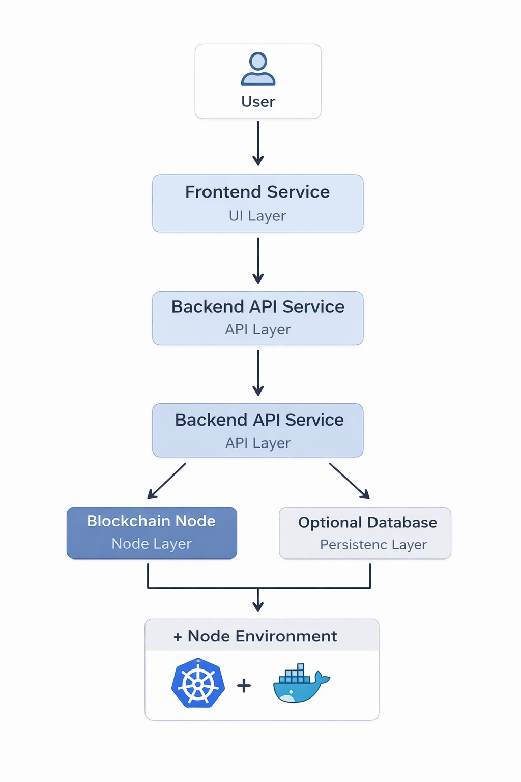

Logging & Monitoring Plan

1. Application Logging
The system captures application-level logs to monitor functionality and detect issues.
Includes:
- Backend logs – Application runtime logs and business logic execution.
- API request logs – Incoming requests, response status codes, and response times.
- Error logs – Exceptions, failures, and unexpected behavior.
- Blockchain transaction logs – Transaction submissions, confirmations, and failures.
Purpose:
To track system behavior and troubleshoot application-level issues
2. Container Logging
Container-level logs are collected to monitor infrastructure health.
Includes:
- Docker logs – Container execution logs.
- Kubernetes pod logs – Pod lifecycle events and runtime logs.
Access Methods:
docker logs <container-id>
kubectl logs <pod-name>
Purpose:
To detect crashes, restarts, and deployment-related issues.

Metrics Monitoring
Key performance and health metrics are continuously monitored.

Infrastructure Metrics
- CPU usage
- Memory usage
- Pod health status
- Container restart count

Application Metrics
- API latency
- Error rate
- Request volume
Purpose:
To ensure system stability and performance optimization.

Tools Used

4.1 Prometheus – Metrics Collection & Monitoring
Prometheus is used as the primary monitoring system for collecting and storing time-series metrics.

Responsibilities:
- Scrapes metrics from application /metrics endpoints
- Collects Kubernetes cluster metrics
- Monitors:
  - CPU usage
  - Memory usage
  - Pod health status
  - Container restart count
  - API request count
  - API latency
  - Error rate

How It Works:
- Backend service exposes metrics endpoint (/metrics)
- Prometheus periodically scrapes metrics
- Metrics are stored in Prometheus time-series database
- Metrics are queried by Grafana for visualization

Example Metrics Collected:
- http_requests_total
- http_request_duration_seconds
- container_cpu_usage_seconds_total
- container_memory_usage_bytes
- kube_pod_status_phase

Benefits:
- Real-time monitoring
- Historical data storage
- Query-based metric analysis (PromQL)
- Supports alert rule configuration

4.2 Grafana – Dashboard Visualization & Observability
Grafana is used for visualizing the metrics collected by Prometheus.

Responsibilities:
- Displays real-time dashboards
- Shows system health overview
- Tracks performance trends
- Visualizes error rate and latency

Dashboards Include:
- CPU & Memory usage dashboard
- Kubernetes pod health dashboard
- API performance dashboard
- Error rate monitoring panel
- Blockchain transaction status panel

Benefits:
- Interactive dashboards
- Time-range analysis
- Graph-based monitoring
- Customizable visualization panels

